- Requirements Analysis

This section presents the requirements analysis of the system “Beauty Personalized by AI”. It identifies system actors, defines the product backlog, and outlines all functional and non-functional requirements.

3.1 List of Actors
Actors represent the entities that interact with the system.

Primary Actors
- Customer
- Register and login
- Search salons and services
- Book appointments
- Receive AI recommendations
- Make payments
- Give ratings and reviews
- Salon Owner
- Create and manage salon profile
- Add services and pricing
- Manage bookings
- View customer feedback
- Admin
- Manage users and salons
- Approve/reject salons
- Monitor system activities
- Generate reports

Secondary Actors
- AI System
- Recommends hairstyles and services
- Detects face shape and skin tone
- Payment Gateway
- Processes online transactions

3.2 Product Backlog

The product backlog contains all system features described as user stories. Each item includes priority, acceptance criteria, and story points.

3.2.0 Agile Concepts
This project follows the Agile methodology for software development. The following concepts are used to manage and organize the product backlog.
Link for WBS Diagram:
https://miro.com/app/board/uXjVGd-LPz8=/

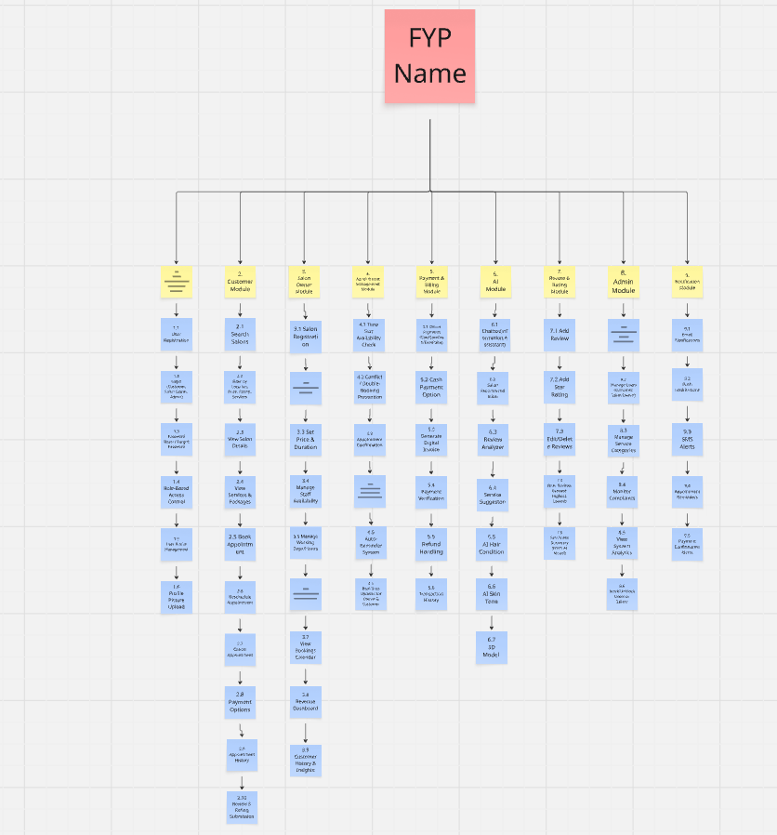

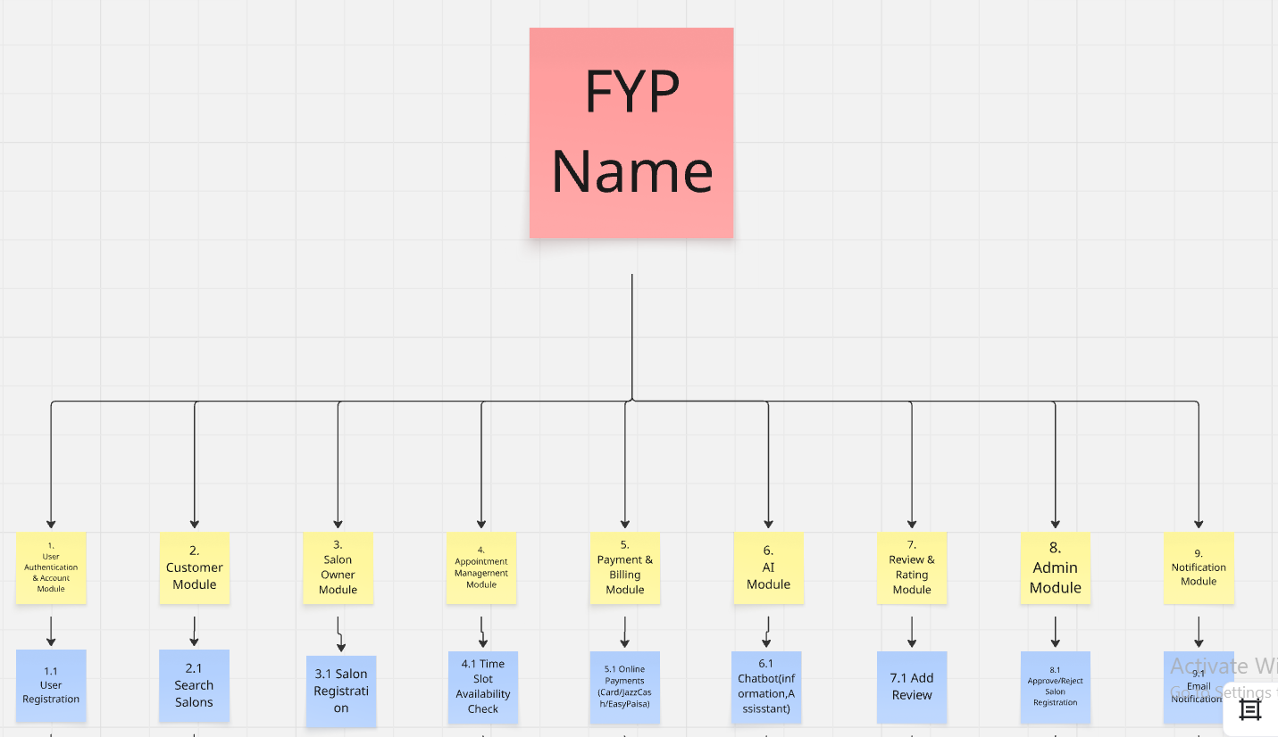

- Sprint
A sprint is a fixed time period during which the development team completes a set of tasks and delivers a working product increment.
Sprints typically last 2 to 3 weeks in this project. Each sprint includes planning, development, testing, and review.
- Epic
An epic is a large user story that cannot be completed in a single sprint. It represents a major functionality of the system.
Epics are divided into smaller user stories for implementation.
Example: "Implement booking system"
- Feature
A feature is a specific functionality within an epic that provides value to the user.
Features are smaller than epics and can be completed within a sprint.
Example: "Select appointment time" "Online payment"
- User Story
A user story is a short description of a system feature from the user's perspective.
Format:
As a , I want so that
Example: As a customer, I want to book an appointment so that I can visit the salon easily.
- Acceptance Criteria
Acceptance criteria define the conditions that must be met for a user story to be considered complete.
They describe the expected behavior of the system.
Example:
User Story: As a user, I want to reset my password so that I can access my account.
- Acceptance Criteria:
- User can enter email to request reset
- System sends reset link
- Link expires in 24 hours
- User can set new password

- Story Points
Story points are used to estimate the effort required to complete a user story.
They represent complexity, effort, and risk, not time.
Common scale: 1, 2, 3, 5, 8, 13
2–3 → Simple task
5 → Medium task
8 → Complex task

- Backlog Grooming
Backlog grooming is the process of reviewing and updating the product backlog regularly.
It includes:
- Refining user stories
- Breaking large tasks into smaller ones
- Estimating effort
- Prioritizing tasks
- Adding or removing backlog items

- Importance

- Improves sprint planning
- Increases team productivity
- Keeps backlog up to date
- Reduces project risks

3.2.1 Salon Catalog

PB-ID | User Story | Priority | Acceptance Criteria | Story Points | Status
SC-01 | As a salon owner, I can create a salon profile | High | Profile includes name, services, and location | 5 | Pending
SC-02 | As a customer, I can browse salons | High | List of salons displayed | 5 | Pending
SC-03 | As a customer, I can view salon details | High | Shows services, prices, reviews | 3 | Pending
SC-04 | As a customer, I can filter salons | Medium | Filter by rating, price, location works | 3 | Pending

3.2.2 Account Management

PB-ID | User Story | Priority | Acceptance Criteria | Story Points | Status
AM-01 | As a user, I can register/login | High | User authenticated successfully | 5 | Pending
AM-02 | As a user, I can update profile | Medium | Profile updated correctly | 3 | Pending
AM-03 | As a user, I can reset password | Medium | Reset email sent | 3 | Pending
AM-04 | As admin, I can manage users | High | Admin can block/edit users | 8 | Pending

3.2.3 Service Creation

PB-ID | User Story | Priority | Acceptance Criteria | Story Points | Status
SV-01 | As salon owner, I can add services | High | Service added successfully | 5 | Pending
SV-02 | As salon owner, I can update services | Medium | Changes saved | 3 | Pending
SV-03 | As salon owner, I can upload images | Medium | Images displayed correctly | 3 | Pending

3.2.4 Booking Services

PB-ID | User Story | Priority | Acceptance Criteria | Story Points | Status
BK-01 | As user, I can book appointment | High | Booking confirmed | 8 | Pending
BK-02 | As user, I can select time slot | High | Available slots shown | 5 | Pending
BK-03 | As user, I can make payment | High | Payment processed | 8 | Pending
BK-04 | As user, I can cancel booking | Medium | Booking updated | 5 | Pending

3.2.5 Salon Admin Control

PB-ID | User Story | Priority | Acceptance Criteria | Story Points | Status
SA-01 | As admin, I can approve salons | High | Salon approved/rejected | 5 | Pending
SA-02 | As admin, I can block users | High | User access restricted | 5 | Pending
SA-03 | As admin, I can monitor system | Medium | Dashboard shows data | 5 | Pending

3.2.6 Viewing Services

PB-ID | User Story | Priority | Acceptance Criteria | Story Points | Status
VS-01 | As user, I can view services | High | Services displayed | 3 | Pending
VS-02 | As user, I can view prices | High | Prices visible | 2 | Pending
VS-03 | As user, I can view availability | Medium | Slots shown | 3 | Pending

3.2.7 Appointment Completion

PB-ID | User Story | Priority | Acceptance Criteria | Story Points | Status
AC-01 | As system, mark appointment complete | High | Status updated | 3 | Pending
AC-02 | As user, view completed bookings | Medium | History visible | 3 | Pending

3.2.8 Miscellaneous

PB-ID | User Story | Priority | Acceptance Criteria | Story Points | Status
MS-01 | As user, receive notifications | Medium | Notification sent | 3 | Pending
MS-02 | As user, view FAQ | Low | FAQ page loads | 2 | Pending

3.2.9 Forms

PB-ID | User Story | Priority | Acceptance Criteria | Story Points | Status
FO-01 | As user, submit feedback | Medium | Feedback stored | 3 | Pending
FO-02 | As user, contact support | Medium | Message delivered | 3 | Pending

3.2.10 Announcements

PB-ID | User Story | Priority | Acceptance Criteria | Story Points | Status
AN-01 | As owner, post offers | Medium | Offer displayed | 3 | Pending
AN-02 | As user, view promotions | Medium | Promotions visible | 2 | Pending

3.2.11 AI Features

PB-ID | User Story | Priority | Acceptance Criteria | Story Points | Status
AI-01 | As user, get hairstyle recommendations | High | AI suggests styles | 8 | Pending
AI-02 | As user, use chatbot | High | Chatbot responds | 8 | Pending
AI-03 | As system, detect face shape | High | Detection works | 8 | Pending

3.2.12 Non-Functional Requirements

PB-ID | Requirement | Priority | Acceptance Criteria | Story Points | Status
NFR-01 | Performance | High | Response < 3 seconds | 5 | Pending
NFR-02 | Security | High | Data encrypted | 8 | Pending
NFR-03 | Scalability | Medium | Handles multiple users | 5 | Pending

3.2.13 Affiliates

PB-ID | User Story | Priority | Acceptance Criteria | Story Points | Status
AF-01 | As partner, refer users | Low | Referral tracked | 3 | Pending
AF-02 | As system, manage rewards | Low | Rewards calculated | 3 | Pending

3.2.14 Comments / Reviews

PB-ID | User Story | Priority | Acceptance Criteria | Story Points | Status
CM-01 | As user, rate salon | High | Rating saved | 3 | Pending
CM-02 | As user, write review | Medium | Review displayed | 3 | Pending

3.2.15 Service Evaluation

PB-ID | User Story | Priority | Acceptance Criteria | Story Points | Status
EV-01 | As user, evaluate service | Medium | Feedback stored | 3 | Pending
EV-02 | As admin, analyze feedback | Medium | Reports generated | 5 | Pending

3.2.16 Reporting

PB-ID | User Story | Priority | Acceptance Criteria | Story Points | Status
RP-01 | As admin, view reports | High | Reports generated | 5 | Pending
RP-02 | As owner, view earnings | High | Earnings displayed | 5 | Pending

3.3 Figma UI/UX Designs
Initial mockup screens will be inserted here. Each screen will be given an appropriate prototype id.e.g.
Link of Figma Designs:
https://www.figma.com/design/jYOQ3d5CHRTaHc4D7cmhHQ/Untitled?node-id=0-1&p=f&t=pIuxl5g31VcLAcFv-0


